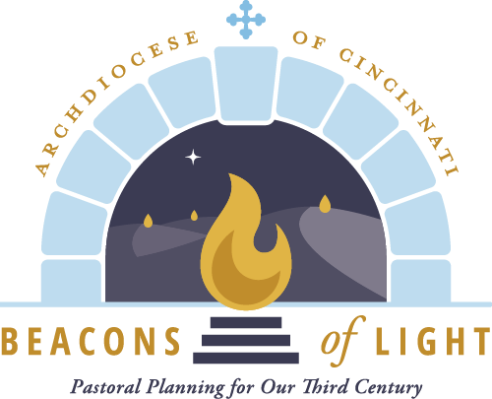
Proactive Parish Family Communication
Regarding Beacons of Light

We encourage all pastors to regularly communicate with their Family of Parishes about Beacons of Light as it relates to both consolidation and evangelization. This can be from the ambo as part of a homily, in parish bulletins and other print media, in short videos, and in social media within the Family of Parishes. Below are sample bulletin articles published by Fr. Ed Pratt to his Family of Parishes. These are provided simply as an example of good practice and you are free to adapt them for your own use.

It’s Official! Our Parish of Families Begins Our Journey Together
Friday, July 1, 2022, marked the official beginning of the archdiocese’s Beacons of Light program, establishing 57 “Families of Parishes” in our archdiocese. The prior pastoral planning program had around 112 pastoral regions constructed from just over 200 parishes. As we begin our journey as faith-filled brothers and sisters in Kettering, it’s important to know a few things:
- Our Family is very large and has many gifts and some challenges. With over 20,000 registered members, 155 employees and a $12,000,000 annual budget, we are no small operation.
- This is much more than simply sharing a pastor and priests. We will be challenged to look at how we can best fulfill our Catholic mission in this area for the coming years.
- Some things will remain the same as we come together. Each parish location will continue to have its own Mass times, finances, school, faith education, RCIA, staff, property and related ministerial services. We will be challenged to form committees and have dialogue on how we can share more in the future.
- Change is hard but necessary. This program will take us into the next generation of parish development.
- There is a lot more to say and to know. There also are a lot of questions.
Let’s hold one another in prayer as we continue to be Beacons of Light and become the Kettering Catholic Community. Let’s continue on our journey with God and one another.
Peace, Father Ed

Change is Not Easy… “Are You Backing Away from the Cross?”
The Beacons of Light Initiative has brought about a number of changes. As this is a planned five year program, we know the process will bring about even more development as we continue to work together as three parishes, forming one collaborative Kettering Catholic Community. The changes have affected parishioners, clergy, staff, students and even our secular community. We are challenged to look at being Church in a new way. There certainly have been blessings with our challenges as we work together. It has been wonderful to meet so many new people. I have been encouraged and affirmed by the number of parishioners who have told me they are praying for me and my brother priests. We know the power of prayer—thanks. Recently I was talking with a priest friend who said that during a discussion with his spiritual director, he mentioned the number of challenges that have come with Beacons of Light. The spiritual director posed the question, “Are you backing away from the cross?” I found this question to be one of great depth. Change is not easy, but neither is the cross. As we continue to celebrate the successes of our work together, let’s pray that we will take up our cross and let the Spirit guide us on our new pathway. Let’s also pray for patience. We continue on our journey with God and one another.
Peace, Father Ed

Is That True???... I Heard…
With all the changes that Beacons of Light has brought us and will continue to bring us, I thought I would share with you some things that have been asked of me. Some are really interesting and some lead me to wonder where one heard such things. Please no rumors.
Q: “Will you tell me the date that ____ parish is closing?”
A: There is no such date. All three of our parishes are continuing to operate. We are three working together as one. Any discussion of closing a site is years away—if at all.
Q: “Why do the priests have to rotate?”
A: We rotate because each is assigned by the Archbishop to all three places within the family.
Q: “We had 3 active priest pastors before Beacons, why can’t we just have the three priests each be a pastor at one of the Kettering locations?”
A: The Beacons of Light program helps with transitions for priests in leadership as pastors. Pastors who are nearing retirement were looking to ease into retirement and were unable to do so because of increasing demands. Newly ordained priests were named pastors too soon and the administrative duties demanded time that is better spent learning sacramental duties. Larger families like ours have a combination of priests in these situations. Fathers Chris, Paul & Ed were part of a group with proper age and experience to pastor Families of Parishes.
Q: “Do you know that is has been hard to get to know our priests since they rotate between the locations and we don’t see them as often as we would like?”
A: Yes, we as priests are aware of this. We want to know you as well, but parishioners and priests have to deal with the current circumstances as they are. It has not been easy for anyone, and so we’ll all need to be patient with the process.
Have questions? Ask a staff member. Please don’t assume things that you are questioning and have not verified are true. More info in future bulletins. You can find answers to similar questions at catholicaoc.org/beacons-of-light/learn-more.
Let’s continue on our journey with God and one another.
Peace, Father Ed

More of — Is That True?... I Heard…
A couple of weeks ago, my column had some Q & A comments that many people found helpful, so I decided to do some more. Remember to ask questions to verify what you may have heard. Please no rumors.
Q: “How is Father Chris? How is Father Paul?” A: My recent contacts with them have shown that they are adapting to their new assignments. We should keep them in our prayers. I’m sure they would enjoy a card or note from any of us in Kettering. Find addresses on the websites. Father Chris is at St. Margaret of York in Loveland; Father Paul is at St. John in Harrison.
Q: “Why are we called the Kettering Catholic Community?” A: Simply—all three parishes have Kettering addresses. We recognize parishioners come from many other surrounding communities. No one is excluded, all are welcome. Of note: the archdiocese refers to us as NE-5, derived from Family 5 of the Northeast Deanery. I think Kettering Catholic Community is more personal!
Q: “I’ve heard that one parish is in a much better financial position than the others.” A: This is a rumor not based in fact. All 3 parishes have similar amounts of savings, facilities in good repair and no plans for major construction. Our Family is financially stable.
Q: “How long will we be guided by the Beacons of Light process?” A: The Beacons of Light process is a program that will be a continual part of governing the archdiocese. The timelines provided by the archdiocese allow for a few years of planning for our long term future as a Family of Parishes. We will be working together to define our future opportunities.
Have questions? Ask a staff member. Please don’t assume things that you have heard and have not verified are true. More info in future bulletins. Let’s continue on our journey with God and one another.
Peace, Father Ed

